What is Lacrosse?
Lacrosse is a team sport played with a lacrosse stick and and lacrosse ball. Players use the head of the lacrosse stick to carry, pass, catch, and shoot the ball in the goal.

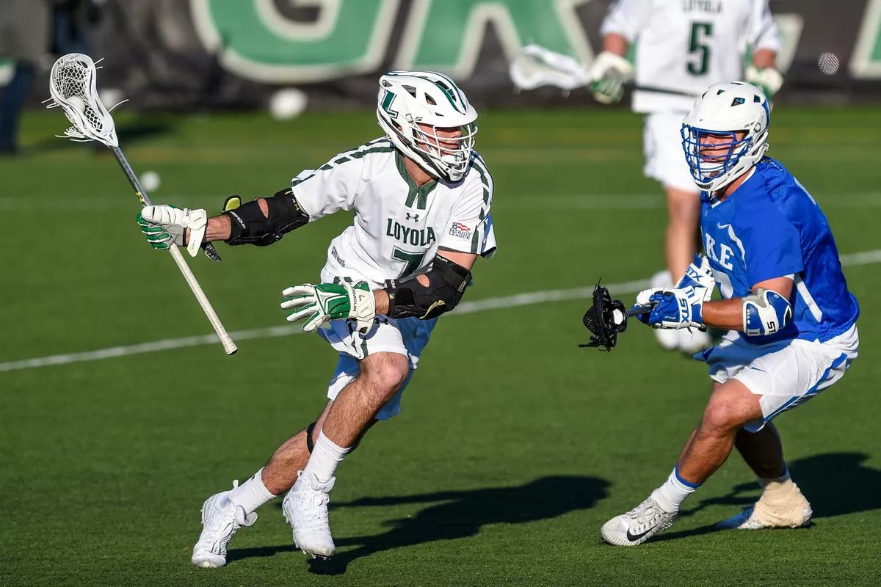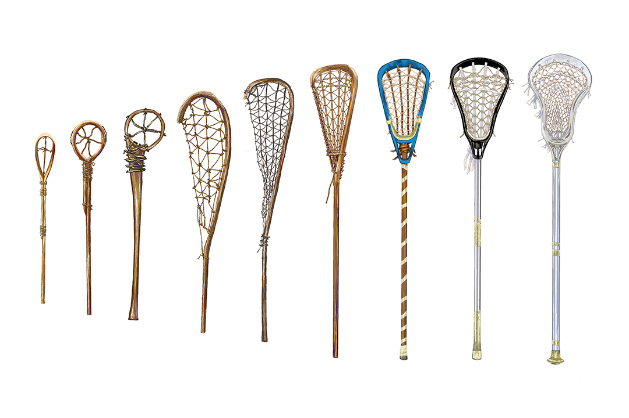

History
Lacrosse is North America's oldest sport. It was played by early Native Americans to solve disputes between neighboring tribes. The game would go on for days and go over miles and miles of land. A Canadian dentist named William George Beers created the beginnings of field lacrosse and added rules to make the game played within a specific field size, team size, and type of sticks.

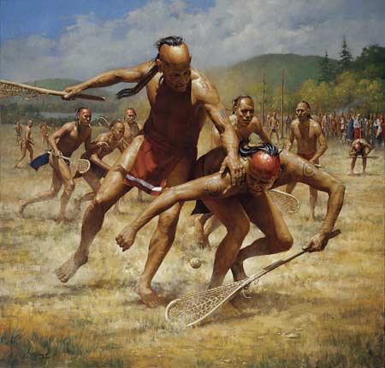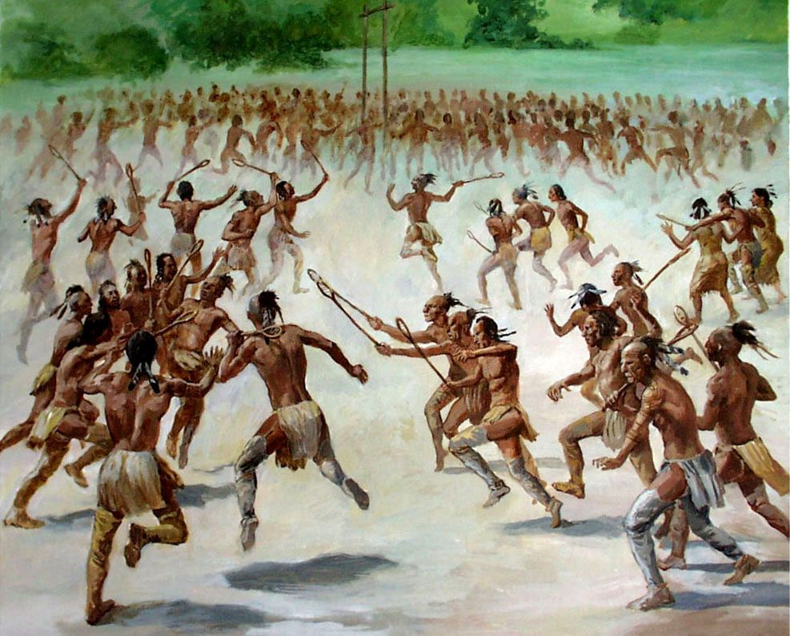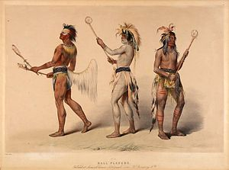

Formats
There are two main types of lacrosse. Field and Box Lacrosse. We play field.

Field Lacrosse | Box Lacrosse
Field lacrosse is a full contact outdoor men's sport played with ten players on each team. | Box lacrosse is played between two teams of five players and one goalie each, and is traditionally played on an ice hockey rink once the ice has been removed or covered.

Practice

- Players will show up for practice Mon-Thur. 4:30 PM – 5:30 PM at Forest Glen Elementary starting in April. Games begin in April.

- Your son will be placed into one of four position categories:

Offense | Defense | Middies | Goalies
The scoring position. | The defending position. | Play both offense and defense. | Protect the Goal.

*Whoever plays goalie will be able to get all their equipment rented to them for FREE from us. Won't need to buy any sticks or equipment!

Rules & Expectations for Players

- Practices and game participation are mandatory. Please provide coaches with 24 hrs notice if you plan to miss practice and at least 2 days notice if you can’t make it to a game.
- Players can only miss a total of 3 practices or they are kicked off the team.
- When you miss practice even if you have notified Coach, your son will still have to run the next practice he attends to make up for it.
- Players are expected to be properly dressed for practice and ready to take the field by 4:00 PM or when the bus from Belzer arrives if your commuting.
- This means shorts and all gear. If you do not wear proper attire or are missing gear your son will be sitting out and will have to run for failing to be prepared!
- Your must come to practice ready to learn how to play lacrosse. This is not a day care! We are coaches with experience trying to prepare your son to play lacrosse in high school.
- Talking back to coaches, not listening to instructions, whining, chatting with other players while a coach is speaking is not acceptable. If a player does not listen to coaches he will be kicked off the team. It has happened before!
- Throwing a ball at any players, being verbally abusive, or cursing is also not allowed!
- Treat the coaches with respect, come with an open mind ready to practice, and you will go far!

“I am the wisest man alive, for I know one thing, and that is that I know nothing.”
― Plato, The Republic

What We Need from Parents

- Pick up your son on time when practice is over! Coach's time is valuable!
- Carpooling home from practices & games
- Food donations for the end of year banquet with high school programs
- IMPORTANT - Parent support(volunteers)will be needed (Similar to Booster Club) for gate fees, concessions, stats (?), etc.

What You Can Expect from Coaches

As coaches, we will do everything conceivable to help mentor your son as a lacrosse player, and as a person.

Double-Goal Coaching
- Goal #1: Teach your son the fundamentals of lacrosse and give him the foundational experience he needs to be prepared to play at the high school level.
- Goal #2: Have FUN!

Coach Schroeder
(Head Coach)
317-753-0794
andrewschroeder@msdlt.k12.in.us

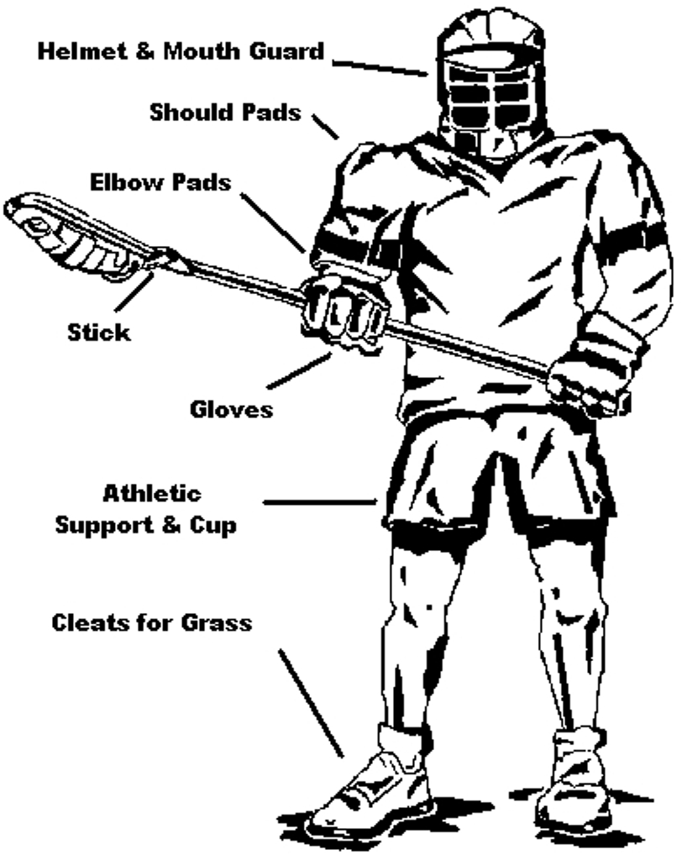
Equipment & Requirements for Participation
- Equipment:
- Stick (with head and strung mesh)
- Helmet
- Shoulder Pads
- Elbow Pads
- Gloves
- Mouthpiece
- Athletic Cup
- Cleats(soccer/football/lacrosse) not softball or baseball
- For girls-goggles girls goalies wear a helmet and pads

Where to Buy
- Empire Lacrosse: Students can purchase new gear from Empire.
2. Used Gear can be purchased as well at places such as Play it Again Sports. We recommend the location at Olio Rd. and 116th St. Please understand and beware of the risks associated with the use of pre-owned gear, including helmets!
3. Rental Gear from Lawrence Lacrosse. The club has a limited number of inspected and recertified gear sets for rent:

If you need equipment, please tell Coach S what you need.

Requirements for Participation

Here are links to the three things your son needs to start using the weight room in November:

- FCV Middle School: 20 MSDLT Student-Athlete Required Form
https://app.smartsheet.com/b/form/e13eabdadfed488d831fa2febce58c7c

Completion of this form and submission of the 4-page student physical is required prior to participating in any athletic conditioning or practices. If student-athlete is under the age of 18, form should be completed by the legal parent/guardian.

2. PHYSICAL FORMS

Here is a link to a blank physical form to take with you to your doctor's office:

http://www.ihsaa.org/Portals/0/ihsaa/documents/quick%20resources/IHSAA%20PPE%202017-18.pdf

3. US LACROSSE MEMBERSHIP

https://www.uslacrosse.org/membership

US Lacrosse Membership gives them insurance if he or she gets hurt while playing and a free subscription to us lacrosse magazine.

$25 Transportation Fees (District takes out for our games)
$25 TOTAL for 2020 Season to FCV Athletics
$35 US Lacrosse (Gives your son insurance and magazine subscription)

GRAND TOTAL $60

How to Prepare for the Spring Season

- Watch Lacrosse:

Most kids this age do not watch lacrosse and don’t understand the context of what they are doing when they go out on the field and play.There are so many free games to watch online.

Here is a list of a few places to watch field or box lacrosse with your son:

Youtube | LAX Sports Network | National Lacrosse League | Premier Lacrosse League
FREE! NO EXCUSES!  Type in and search:  Box lacrosse full game  or…  Field lacrosse full game | FREE! Just Download App on device or TV!  MAKE SURE YOU DOWNLOAD AND WATCH! | BOX LACROSSE  FREE GAME OF THE WEEK to watch at Bleacher Report LIVE and on Twitter & FB LIVE  AIRS NOV-MAY  ALSO Free replay games on YouTube all year. | FIELD LACROSSE  Airs FREE in the summer on NBC Sports!

- Get on the WALL!

If your son thinks his stick skills are good enough… Then he is wrong! I played in high school and mine are still not good enough!

The best thing he can do to get prepared for this season is to throw against the wall or a rebounder! Get on youtube and type in: lacrosse wall ball drills to see what to do!

- Fall Sports, Offseason Camps, Box & Field Lacrosse:

- We love multisport athletes and encourage your son to be one. If you are playing a fall/winter sport, then you are exempt from lacrosse offseason training. If your son is not playing a fall/winter sport, then lacrosse off season training and activities are mandatory.
- We will a fall multi-week camp next fall here at FCV. Laxinlawrence.org
- We will have a summer recreational league in Lawrence. Laxinlawrence.org
OTHER LOCAL WAYS TO PLAY OFFSEASON LACROSSE:
- Origins Lacrosse Club offers box lacrosse games for youth in the summer, fall, and winter. To learn more, attend a clinic, and register to play box lacrosse go to: https://originslc.com
To learn more, attend a clinic, and register to play box lacrosse go to: https://originslc.com

